# CSP554—Big Data Technologies

## Assignment #3 (Modules 03a & 03b, 15 points)

**6) (5 points) Submit a copy of this modified program and a screen shot of the results of the program’s execution as the output of your assignment.**

**WordCount2.**

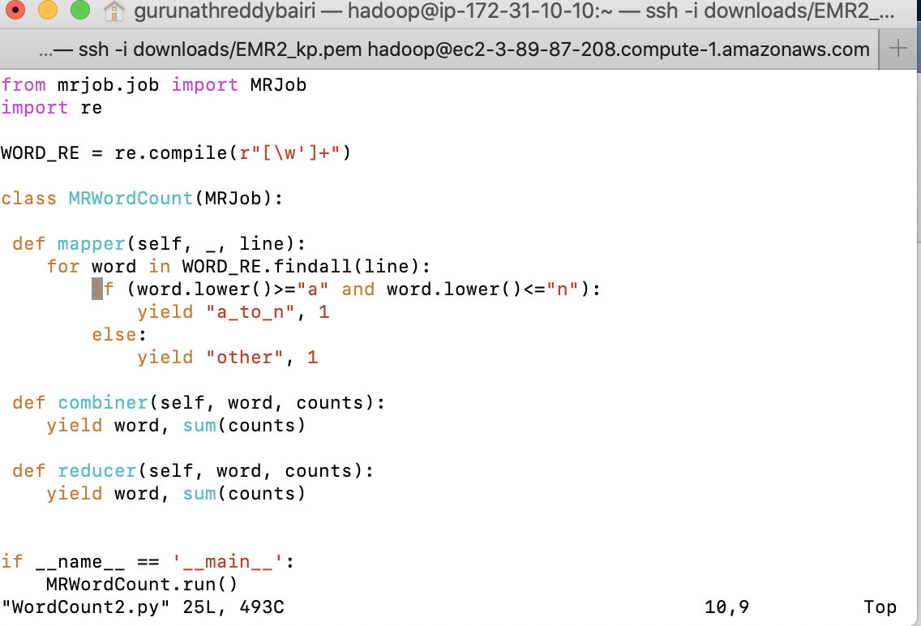

**Copying WordCount2.py from local to home/Hadoop**



**o/p for the WordCount2.py**

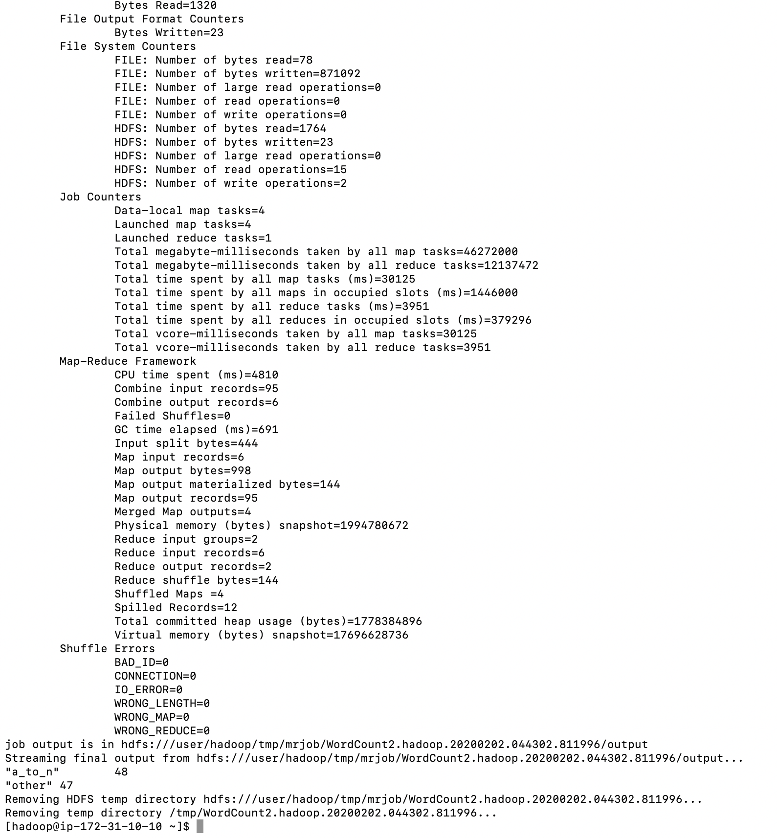

**10) (5 points) Submit a copy of this modified program and a screen shot of the results of the program’s execution as the output of your assignment.**

**Salaries2.py**

**Copying Salaries2.py from local to home/Hadoop**

**Output**

**12) (5 points) Review the slides 15-22 in lecture notes Module 3b. Now write a program to perform the task of outputting a count of the number of movies each user (identified via their user id) reviewed.**

**MovieCount.py**

**Output**

